**NLP Chatbot Developing using Dialogflow**

**Design Document**

**Version 1.0**



**Group Id: F24PROJECT8DE28 (bc210415622)**

**Supervisor Name :< Abdullah Qamar (**[abdullah.qamar@vu.edu.pk](mailto:abdullah.qamar@vu.edu.pk) )

**Revision History**

|  |  |  |  |
| --- | --- | --- | --- |
| **Date (dd/mm/yyyy)** | **Version** | **Description** | **Author** |
| 27/02/2025 | 1.0 | This project is about creating a smart chatbot for a restaurant website using Google Dialogflow. The chatbot will help customers with tasks like **reserving tables, placing orders, checking the menu, and getting support**. It will understand natural conversations and respond accurately, making interactions smooth and hassle-free. The system will connect with a **backend (PHP/Python) and a MySQL database** to handle requests efficiently. This chatbot will not only make things easier for customers but also **reduce the workload for restaurant staff and improve overall operations.** | Bc210415622 |
|  |  |  |  |
|  |  |  |  |
|  |  |  |  |

**Table of Contents**

1. Introduction of Design Document **page # 4 to 5**
2. Entity Relationship Diagram (ERD) **page # 06**
3. Sequence Diagrams **page # 07**
4. Architecture Design Diagram **Page # 08**
5. Class Diagram  **Page # 08**
6. Database Design **Page # 09**
7. Interface Design **Page # 10 to 12**
8. Test Cases **Page # 13 to 21**

1. Introduction of Design Document

**Introduction - Overview of the Project**

With the increasing demand for automation in the restaurant industry, businesses are looking for smarter ways to enhance customer service and streamline operations.

This project focuses on developing an AI-powered chatbot using Google Dialogflow that will assist restaurant customers by handling reservations, answering frequently asked questions, and navigating the menu. The chatbot will be integrated into a well-designed website, providing users with a seamless experience for ordering food, booking tables, and getting instant responses to their queries.The system will consist of a web application where customers can interact with the chatbot, browse the menu, and make reservations.

The chatbot will use NLP (Natural Language Processing) to understand customer requests and provide relevant responses. The backend, built using PHP or Python, will handle database operations, ensuring that reservations and orders are stored securely in MySQL. The project aims to improve efficiency, reduce manual workload for restaurant staff, and provide a user-friendly solution that enhances the overall dining experience.

* **Entity Relationship Diagram (ERD)**  
  This is like a blueprint of how different parts of the system are connected. It shows things like customers, reservations, and orders, along with how they relate to each other, making database design easier.
* **Sequence Diagrams**  
  These diagrams help visualize step-by-step interactions between the user, chatbot, and system. For example, they show what happens when a customer books a table or places an order, ensuring everything flows smoothly.
* **Architecture Design Diagram**  
  This provides a big-picture view of how everything is connected—like the chatbot, website, database, and backend system. It helps in understanding how data moves and how different components communicate.
* **Class Diagram**  
  This part focuses on defining different elements of the system, such as users, chatbot, orders, and reservations. It helps developers understand how different parts work together when writing code.
* **Database Design**  
  This ensures that all data—like customer details, orders, and reservations—is stored in a structured and organized way. A well-planned database makes retrieving and managing information quick and efficient.
* **Interface Design**  
  This is about making the chatbot and website easy to use. It focuses on how the chatbot will look, where it will be placed, and how users will navigate the menu, place orders, and make reservations.
* **Test Cases**  
  This step involves checking whether everything is working properly. Different scenarios are tested to ensure that the chatbot responds correctly, orders are processed smoothly, and no errors occur during interactions.

1. **Entity Relationship Diagram (ERD)**



1. **Sequence Diagrams:**

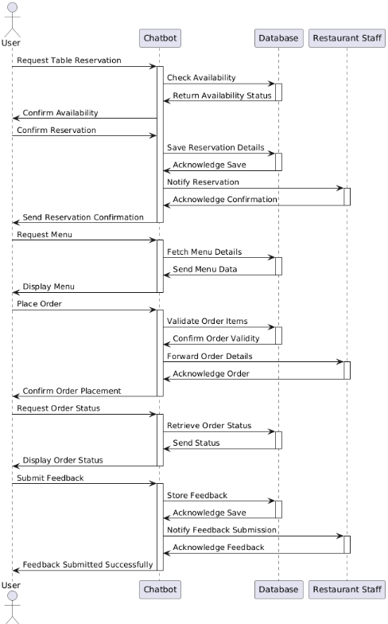

1. Architecture Design Diagram



1. **Class Diagram:**



1. **Database Design:**



1. **Interface Design:**

* Home page interface

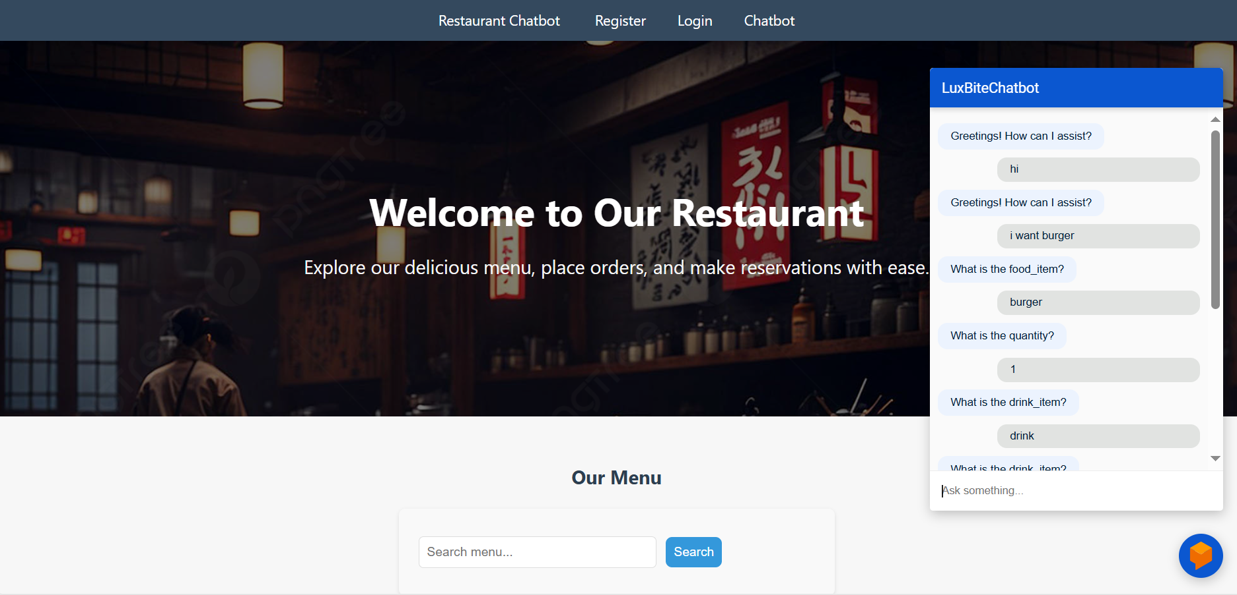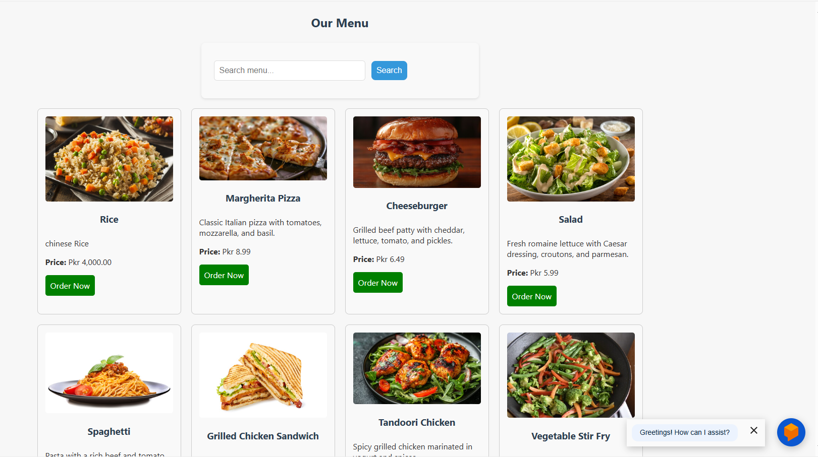

* Restaurant Chatbot

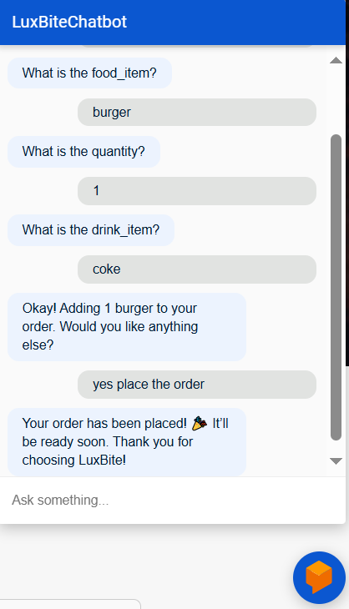

* Customer Support

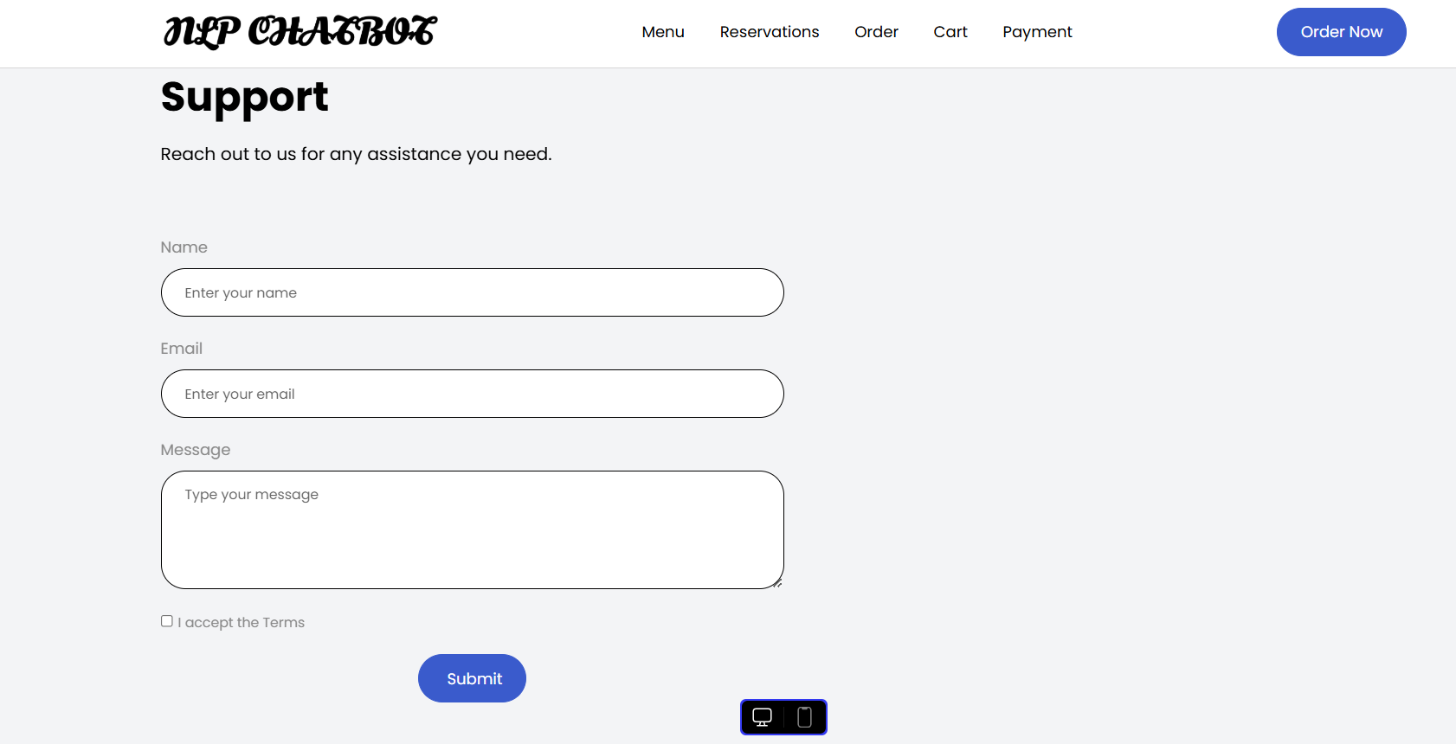

1. Test Cases

**Case # 01**

**Test Case: User Makes a Table Reservation:**

|  |  |
| --- | --- |
| **Heading** | **Description** |
| Precondition | User is logged in and on the home page. |
| Action | 1. Click “ Table Reservation” Button 2. Fill in reservation details. 3. Submit the form |
| Expected Result | Reservation request is sent, and a confirmation message is displayed. |
| Tested by | Bc210415622 |
| Result | Pass |

**Case # 02**

**Test Case: User Logs into the System**

|  |  |
| --- | --- |
| **Heading** | **Description** |
| Precondition | User is on the login Page. |
| Action | 1. Enter email and password 2. Click “Login” button. |
| Expected Result | User is redirected to the home page. |
| Tested by | Bc210415622 |
| Result | Pass |

**Case # 03**

**Test Case: User Fails Login Due to Incorrect Credentials.**

|  |  |
| --- | --- |
| **Heading** | **Description** |
| Precondition | User is on the login Page. |
| Action | 1. Enter incorrect email or password. 2. Click “Login” button. |
| Expected Result | Error message “Invalid credentials” is displayed. |
| Tested by | Bc210415622 |
| Result | Pass |

**Case # 04**

**Test Case: User Views Menu Items.**

|  |  |
| --- | --- |
| **Heading** | **Description** |
| Precondition | User is login in. |
| Action | 1. Click “ Menu” tab. |
| Expected Result | Menu items are displayed correctly. |
| Tested by | Bc210415622 |
| Result | Pass |

**Case # 05**

**Test Case: User Places an Order**

|  |  |
| --- | --- |
| **Heading** | **Description** |
| Precondition | User is logged in and on the menu page. |
| Action | 1. Selected food items. 2. Click “Add to cart” 3. Click “Checkout” 4. Enter delivery details. 5. Click “ Place Order” |
| Expected Result | Menu items are displayed correctly. |
| Tested by | Bc210415622 |
| Result | Pass |

**Case # 06**

**Test Case: User Cancels a Reservation**

|  |  |
| --- | --- |
| **Heading** | **Description** |
| Precondition | User has an existing reservation |
| Action | 1. Go to “My Reservation”. 2. Click “Cancel” on an existing reservation. 3. Confirm cancellation. |
| Expected Result | Reservation is canceled, and a confirmation message is displayed. |
| Tested by | Bc210415622 |
| Result | Pass |

**Case # 07**

**Test Case: User Updates Profile Details**

|  |  |
| --- | --- |
| **Heading** | **Description** |
| Precondition | User is logged in. |
| Action | 1. Go to “Profile”. 2. Click “Save” 3. Edit details (e.g, phone number). |
| Expected Result | Profile is updated successfully |
| Tested by | Bc210415622 |
| Result | Pass |

**Case # 08**

**Test Case: User Interacts with Chatbot**

|  |  |
| --- | --- |
| **Heading** | **Description** |
| Precondition | User is on the home page. |
| Action | 1. Click chatbot icon. 2. Ask a question (e.g., “What are your hours?”). |
| Expected Result | Chatbot respond with relevant information. |
| Tested by | Bc210415622 |
| Result | Pass |

**Case # 09**

**Test Case: User Logs Out**

|  |  |
| --- | --- |
| **Heading** | **Description** |
| Precondition | User is logged in. |
| Action | 1. Click “logout” button. |
| Expected Result | User is redirected to the login page. |
| Tested by | Bc210415622 |
| Result | Pass |